**SMARTCASH**

**STYLE GUIDE AND BRAND IDENTITY**

**Graphic Identity Guidelines**

**Version 1.1, May 2018**

A strong and consistent visual identity of our logo will help keep a consistent look, recognition and familiarity now and in the future. Standardization of colours will go a long way to enforce a reliable and positive impression to our identity in the blockchain space.

**SmartCash** is one word without spaces and each word capitalized.

Do not use SC to abbreviate SmartCash. You may use SmartCash (SMART).

Official font is Source Sans Pro / PT Sans.

**Primary Colors:**

HTML code: #FEC60D   
RGB code: R: 254 G: 198 B: 13  
HSV: 46.06° 94.88% 99.61%

HTML code: #FBFCFC   
RGB code: R: 251 G: 252 B: 252  
HSV: 180° 0.4% 98.82%

HTML code: #000000   
RGB code: R: 0 G: 0 B: 0  
HSV: 0° 0% 0%

HTML code: #f4b517

*Background color:*

RGB code: R: 244 G: 181 B: 23

**Tints derived from #fec60d**  
#fec60d   
#fecb25   
#fed13d   
#fed755   
#fedc6d   
#fee286   
#fee89e   
#feedb6   
#fef3ce   
#fef9e6   
#ffffff

**Shades derived from #fec60d**  
#e4b20b   
#cb9e0a   
#b18a09   
#987607   
#7f6306   
#654f05   
#4c3b03   
#322702   
#191301   
#000000

**Spelling and Capitalization Guide for Features:**  
SmartCash  
SmartNode  
SmartCard  
InstantPay  
SmartRewards  
SmartCash Web Wallet  
SMART

**Social media tags:**

#SmartCash  
$Smart

Do not use on banners/printed collateral, the website is preferred.

**Website Link / URL Formatting:**  
  
Do not include http:// when making a URL. www may be included. The following are acceptable:  
  
www.SmartCash.cc  
SmartCash.cc  
www.smartcash.cc  
smartcash.cc

SmartRewards.cc  
www.smartrewards.cc  
www.SmartRewards.cc  
smartrewards.cc

SMART is the ticker / coin name used for SmartCash exchanges.

**Logo with WordMark to right:**

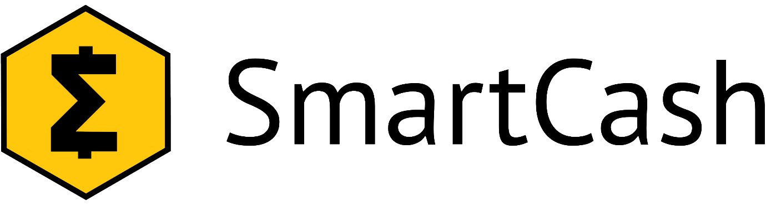

**WordMark below logo:  
  
**

**Logo Large Sigma without WordMark**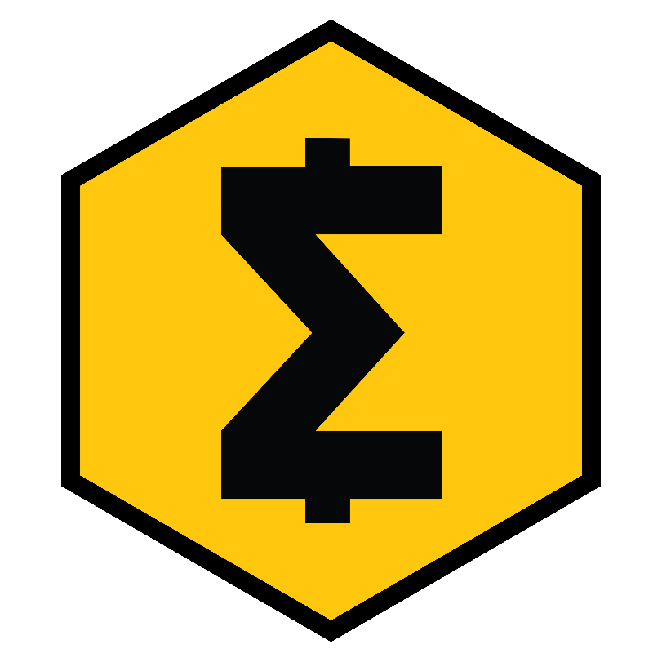

**Logo with WordMark to right on black background:**



**Logo with WordMark below on black background:**



**Community Graphics**

Use cultural icons instead of flags.